Job Title | Internal Communications and Engagement Manager
JD Reference Number | JD_EDOCA_052
Directorate | Corporate Affairs
Team | Communications and Engagement
Internal Communications and Engagement Manager

Grade | 7
Reports To: | Assistant Director - Communications and Campaigns
Accountable to: | Director of Communications and Engagement
Terms and Conditions of Employment | Agenda for Change (AfC)
Line Management Responsibility | No direct reports, but day to day supervision of more junior staff and of a range of suppliers
Hours of work | Full-time
Base | The postholder may be required to travel and work at  any establishment at any time, within the location of the North Central London ICB
Background and Context
NHS North Central London Integrated Care Board (NCL ICB) is a statutory body responsible for planning and allocating health and care resources to improve the lives of people in our five boroughs: Barnet, Camden, Enfield, Haringey, and Islington.

Our local population is large and diverse, with a wide range of health and care needs that are evolving all the time.

We’re committed to improving the health and experience of our patients and residents, working with partners across the North Central London Integrated Care System (ICS) - including Councils, providers, GPs and voluntary and community organisations - to plan and deliver high quality, joined-up and accessible health and care services that put people first.

As an ICB, we’re focused on:

- improving outcomes in population health and healthcare
- tackling inequalities in outcomes, experience, and access
- enhancing productivity and value for money
- helping the NHS support broader social and economic development.
We’re ambitious, driven, and passionate about working collaboratively and creatively to deliver the best health and care possible for our patients and residents through every stage of their lives. Our Population Health and Integration Strategy outlines our vision and priorities and will shape our focus as a system for the coming years.

We’re proud of our staff and the contribution they make and are committed to developing their knowledge and skills in a supportive, inclusive, and values-led organisation.

Overall Purpose of the Role
You will play a lead role across all aspects of NCL ICB’s internal communications and employee engagement function, using a range of digital and offline channels and tactics to effectively communicate our vision, aims, objectives, achievements, and challenges to its employees, inspiring them to play their part in improving population health and reducing the inequalities that affect so many local residents.

You will use your professional expertise to design and deliver a refreshed approach to informing and engaging staff, delivering a programme of measurable activity to bring the ICB’s values and behaviours to life and ensure staff feel informed, involved, engaged, and recognised – clear about the purpose of the organisation and their part within it.

Working closely with colleagues in the People and Culture team, you will also help the organisation to build an engaged and high performing workforce.

Whether helping to attract and onboard the best talent, creating opportunities for staff to have a voice, breaking down silos or recognising staff for the contribution they make, in this role you’ll make a positive contribution to raising staff engagement and driving internal culture change. You will also play a key part in ensuring the ICB feels a genuinely inclusive environment where staff all feel seen and appreciated.

You will support the ICB in its response to business continuity or emergency events, helping to ensure that staff feel well informed and supported to play their part through unforeseen events.

The team
Alt text: The image below is an organogram of the team structure with names of who is in the team. The line manager for this post is Ruth Shulver, Assistant Director of Communications and Campaigns. There are 17 roles in the Communications and Engagement team.

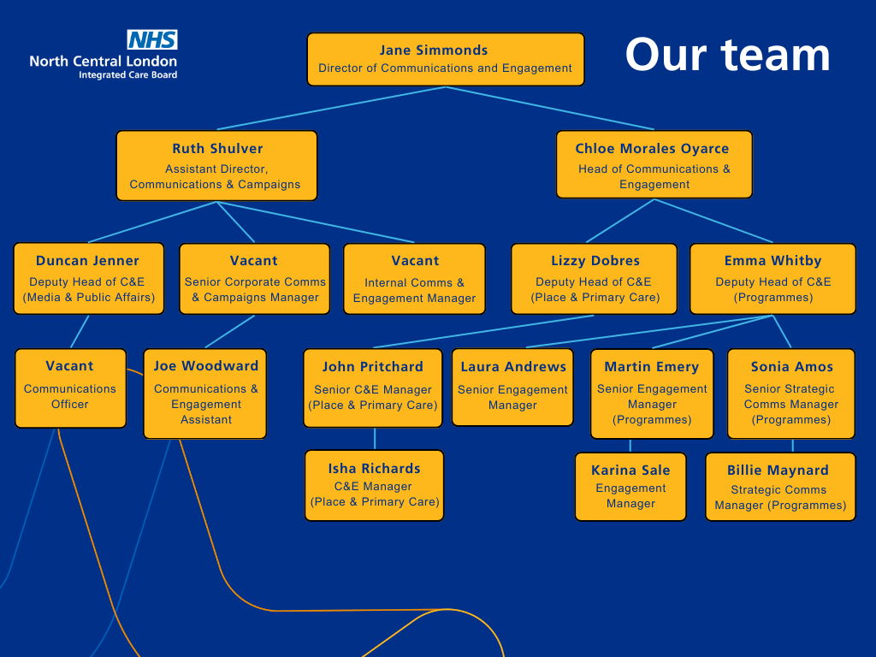
Key Working Relationships

With senior support from the Assistant Director of Communications and Campaigns, you will act as the professional lead for internal communications and engagement, using your knowledge and expertise at both a strategic and operational level. You will play a supervisory role day to day within the Corporate Communications Team.

You’re likely to work closely with the Chief Executive Officer and the Executive Management Team, providing advice across the full range of internal communications and engagement issues and will be expected to work collaboratively with peers and to positively represent the team, with the gravitas to build confidence and influence decision making.
Main Responsibilities
This is a new role within the team, and an exciting opportunity for someone who is looking to build experience, exposure and expertise in a fast-moving, high profile organisation.

- To support the development and manage delivery of an Internal Communications and Employee Engagement Strategy, ensuring it reflects the ICB’s values and rallies staff around the ICB’s key strategic objectives and priorities.

- To communicate and embed our Population Health vision and aims, inspiring staff to play their part in improving the health outcomes and experience for NCL residents.
- To oversee the use of key internal communication channels including a range of regular eBulletins, blogs, webinars, podcasts, video, email etc…regularly reviewing their effectiveness in achieving strategic objectives and adopting a continuous improvement approach.

- To embed a story-telling approach to content development, using real people and case studies to bring our internal communications to life (through articles, video, podcasts, blogs etc…) and ensure staff feel seen and recognised and understand what different strands of the organisation do.

- To ensure that all internal communications activity is accessible and reflects, supports, and encourages diversity and inclusion, actively challenging inequality.

- To support the work of the staff forums and the Engaging our People Forum, working in partnership to help them raise awareness and understanding and drive change.
- In partnership with People and Culture colleagues, to help raise staff engagement within the ICB, including attracting and onboarding the best staff, effectively positioning the leadership team, boosting wellbeing, developing skills, and recognising and rewarding staff for a job well done.

- To help position our corporate values as central to the way we work, engaging staff at all levels to live them day to day - making sure our internal campaigns and projects actively make the connection back to our corporate values and promoting, showcasing and celebrating staff who embody our values.

- To support a shift in the ICB’s culture towards one that is focused on delivering our population health ambitions, empowering people at all levels to make their unique contribution. As part of this, introduce a range of targeted internal communications and engagement channels and tactics for specific internal audiences (including executives and senior leaders, line managers, new starters etc…)

- To play a key role in the development and management of the intranet, involving staff in the co- design of a refreshed platform that enables two-way conversations, content sharing and social interactions, alongside access to the up-to-date information staff need to do their jobs.

- To play a key role in the planning, delivery and development of corporate staff events including staff awards, staff briefings, conferences, webinars, Q and As, Directorate Briefings and so on.

- To develop and implement communications and campaign plans for high-profile internal projects and initiatives, including change programmes as well as sharing internally key external facing campaigns so staff are aware of key activity across the ICB.
- To support the development and delivery of communications activity for directorates with an internal focus, including production of strategic communications plans, materials, and campaigns to ensure staff are well informed about the services they rely on to do their jobs.

- To manage the effective distribution of emails and hard copy items to staff through the development and maintenance of effective distribution lists and monitoring and evaluation of open and click- through rates

- To develop and maintain positive and productive working relationships with managers and other senior officers, in order to secure support for internal communications and engagement activity and to provide professional advice and guidance as required. As part of this, to ensure that relevant system partners are included in internal communications development and activity as appropriate.
- To provide internal communications advice to the Chief Executive and Executive Management Team and ensure they are visible to the wider staff group.

- To contribute to the communications forward planning process and use the content to plan articles and ensure co-ordination of messages in all internal communication channels.

- To draw on best practice from other organisations and sectors, embedding successful ideas and techniques into the ICB’s own internal communications function.
- To ensure that all items of communication produced comply with the corporate identity guidelines and set a corporate example of high-quality writing and design.

- To develop and embed robust methods of measuring and evaluating the impact of our work, using insight, and learning to iterate our approach as needed.
- To support the ICB’s response to emergency and business continuity issues, ensuring that effective on and offline channels are in place to communicate with staff in the event of a crisis and to play a key role in the management of emergency or business continuity events that predominantly affect staff.

- To provide advice to the communications team and wider peers, on how to best deliver their internal communications messages.

- To be fully aware of and abide by NHS England guidance as it relates to internal communications.

- The post may involve some evening and weekend work. The postholder will be part of an on-call rota when required, to ensure we are able to respond to urgent issues out of hours if we need to. (The postholder will receive suitable recompense in accordance with Agenda for Change policies).

- To undertake other duties commensurate to the grade of the post.
Communication responsibilities
  - Translating complex information into easy-to-understand messaging for staff.
  - Advising managers and staff on the best way to deliver a high-performing internal communications and employee engagement function.
  - Creating content and presentations on sensitive issues to staff and managers, planning for reactions or responses that may be upset or hostile.
  - Providing professional advice to senior managers on a range of high-profile or sensitive issues.

Analytical & Judgement
  - Deciding how to plan and design internal communication plans and campaigns adhering to principles of co-production as appropriate.
  - Displaying excellent judgement, with the ability to provide trusted advice and expertise to help the organisation navigate complex internal communications issues.
  - Ability to evaluate engagement with internal communications channels, producing reports on activity for senior members of the communications and engagement team.

Planning and Organisational
  - Contributing to internal communications plans with an impact across the whole organisation considering the overall aims and policies of the organisation.
  - Project manages communications projects

Physical Skills
  - Advanced keyboard skill, requiring fast, accurate typing.
  - Ability to use design software, digital tools (including CRMs, media management systems, campaign planners), video editing and other key tools as appropriate.
  - Presentation skills.

Service and Policy Development
  - The postholder will support the development and delivery of a refreshed strategic approach to internal communications and employee engagement, with support from the Assistant Director of Communications and Campaigns.
  - Proposes changes to communication policies and procedures.

Financial responsibilities
  - To ensure that the communications and engagement budget relating to internal communications delivers value for money, taking every opportunity to explore and secure economies of scale, synergy, and effectiveness. Authorise purchase orders for internal communication budget.

HR responsibilities
  - Supporting the day-to-day supervision and development of more junior members of the team, especially those in the Corporate Communications section.
  - Holding subject matter expertise and advising on internal communications and employee engagement.

Information Management
  - Using analytics and other tools and software to create evaluation reports.
  - Helping to maintain one or more information systems.
  - Ensuring material is as accessible and inclusive as it can be and compliant with NHS guidance and legal requirements.
  - Ensuring any information obtained through online forms is appropriately managed in a manner compliant with data protection legislation and privacy commitments to staff.

Research and Development (includes Risk & Governance Management)
  - Managing databases and undertaking surveys as necessary for internal communications and employee engagement activity.
  - Evaluating content and channel effectiveness and using this to develop and improve.
  - Ensuring Equalities Impact Assessments are conducted as appropriate for internal events.

Freedom to Act (includes Autonomy, Management and Leadership)
  - In the absence of required information, using their initiative to make recommendations about the approach to internal communications challenges,
  - Working to challenging and changing deadlines and priorities, using their own initiative to manage workload while achieving their objectives.
  - Playing a key role in the delivery of a refreshed strategic approach to internal communications and employee engagement, which will include high profile projects such as redeveloping the staff intranet and ensuring the visibility of senior leaders.
  - Is a specialist in internal communication.

Mental Effort
  - Work pattern and demands may be unpredictable.
  - Frequent long periods of concentration required for drafting communications, creating rich content, and providing communications advice.
  - Frequent interruptions to deal with urgent requests or unforeseen events.

Emotional Effort
  - Dealing with difficult or sensitive organisational situations, including leading the internal communications around issues such as re-organisations, service change, changes to leadership structures etc…
The job description is not intended to be exhaustive and it is likely that duties may be altered from time to time in the light of changing circumstances and after consultation with the post holder.
All staff are expected to actively participate in annual appraisals and set objectives in conjunction with their manager. Performance will be monitored against set objectives.
Confidentiality

All ICB staff and contractors working for the ICB have both a common law duty and a statutory duty of confidentiality to protect patient (and indeed any personally identifiable) information and only use it for the purposes for which it was intended. The disclosure and use of confidential patient information needs to be both lawful and ethical.
Information Governance
All ICB staff must keep up to date with the requirements of information governance and must follow ICB policies and procedures to ensure that ICB information is dealt with legally, securely, efficiently and effectively. Staff must appropriately manage the records they create or hold during the course of their employment with the ICB, making the records available for sharing in and confidentiality policies, procedures and guidelines (e.g. Freedom of Information Act 2000, Caldicott guidelines).
Safeguarding
The ICB believe safeguarding is everybody’s business. Abuse causes devastating consequences to children of all ages and damages adult survivors, throughout the rest of their lives. All employees therefore have a duty to safeguard and promote the welfare of children, young people and adults at risk. It is an essential requirement that staff are aware of the local Safeguarding procedures for sharing information about the welfare of any person for whom they have safeguarding concerns. Staff have a duty to ensure they attend training to enable them to recognise the indicators for concerning behaviour and receive safeguarding supervision as appropriate.
Health and Safety

All staff have a duty to ensure the health and safety of themselves and others whilst at work. Safe working practices and health and safety precautions are a legal requirement. ALL accidents must be reported to your manager and you must participate in accident prevention by reporting hazards and following relevant policies and procedures including Moving and Handling guidelines.
Equality and Diversity

The ICB are committed to an Equal Opportunities Policy which affirms that all staff should be afforded equality of treatment and opportunity in employment irrespective of age, disability, gender reassignment, marriage or civil partnership, pregnancy or maternity, race, religion or belief, sex or sexual orientation. All staff are required to observe this policy in their behaviour to their behaviour to other employees and service users.
NCL ICB Values

All aspects of our business, including the relationships we create, our approach to work and the decisions we make are built upon our values. Our values are a commitment to collaborative working to deliver excellent patient experience. The values ensure we remain supportive, transparent and accountable including embracing diversity, as we belief that everyone counts. The values help us to remain efficient in delivering health and high-quality care for all, now and for future generations.

Internal Communications and Engagement Manager Person Specification
If you have a disability and have any special requirements that impact on your ability to meet any of the essential criteria please contact the recruiting manager for the vacancy.
Key A= Application; I = Interview; Asmt = Assessment

Criteria | Essential | Desirable | How Criteria will be identified
Education/ Knowledge and Qualifications | - Educated to Master’s degree  level, or equivalent level of experience in a | - An industry specific degree (public relations,  journalism etc…) | - A

 | communications and engagement role. | may be helpful, but is not essential.
 | - Evidence of continuing professional development or training. | - Up to date knowledge of best practice as it relates to internal communications and employee  engagement. | - I
 | - Thorough understanding of the importance of internal communications and employee engagement and the role they play in a  complex organisation |  | - I/Asmt
Experience | - Experience of managing the delivery of Internal Communications and Engagement in a multi- site/multi-discipline setting  - Experience of developing and implementing effective internal communications plans and strategies, campaigns, and projects  - Experience and knowledge of the full range of internal communications techniques and channels, including new and emerging technology.  - Experience of giving professional advice to senior leaders on how to meet their internal communication and engagement objectives  - Experience of managing the communications around complex or sensitive change and transformation | - Experience of working in the NHS or wider public sector may be helpful but is not essential. | - A/I  - A/I/Asmt  - I/Asmt  - I  - A/I

 | programmes.  - Ability to effectively plan and manage large-scale events - in person, virtual and hybrid  - Experience of managing staff and/or suppliers to ensure high quality results and value for money.  - Experience of embedding and enhancing a corporate brand through the consistent application of both visual identity and corporate voice. |  | - A/I  - A/I  - I
Skills, & Abilities | - Excellent organisational, project management, performance management and financial management skills with a methodical approach to ensuring best quality.  - A thorough understanding of the importance of ensuring all communications is accessible, with practical knowledge of how to ensure this in practice.  - Ability to bring people together around shared plans and priorities, with the ability to co-ordinate internal communications activity and campaigns at system level where appropriate. |  | - I  - I  - I

Communication | - Excellent communications |  | - I/Asmt
 | skills, including oral, written
 | and presentation skills
 | - A skilled writer and storyteller, with a meticulous attention to |  | - I
 | detail and the ability to create
 | engaging, people focused
 | content (including written and
 | video) that brings our
 | narrative to life.
 | - Excellent inter-personal skills with the ability to form and |  | - A/I
 | maintain productive,
 | professional working
 | relationships with a diverse
 | range of individuals and
 | groups and gain the respect
 | and confidence of senior
 | managers.
 | - Ability to work to the highest |  | - A/I
 | standards, demonstrating
 | resilience to pressure and
 | retaining due professionalism
 | at all times.
 | - Excellent professional judgement, with the emotional |  | - I
 | intelligence to manage
 | contentious or sensitive
 | issues, ensuring the internal
 | communications response is
 | measured and thoughtful.
 | - Ability to navigate challenges
 | and stay on course, with the
 | tenacity and drive to prioritise |  | - A/I
 | actions and make things
 | happen.

Effort factors | - Mental effort: frequent interruption, intense concentration when reviewing/writing documents/data, presenting at board meetings |  | - I/Asmt
 | - Emotional effort: imparting unwelcome news to staff or stakeholders, exposed to difficult/emotional meetings. |  | - I
Values and Behaviours | - Commitment to the values and principles of system working agreed across NCL.  - Ability to actively promote equality, diversity, and inclusion within all areas of responsibility |  | - A/I  - A/I

